Final Assessment-Alternative Assessment
Semester | 202520 | Division | CIS
Assessment title in Syllabus | Final_Project_Portfolio | Program | Bachelor of Information Technology/ Bachelor of Information Systems
Course Code | CDS 2413
Course Title | INTRODUCTION TO DATA SCIENCE
Course Instructor |  | CRN
Assessment | Project Deliverable 1 – Data Analysis Report | Submission Date | Week 6
Student Declaration:
Academic Integrity Statement
In accordance with the HCT Academic Integrity Policy
• Students are required to refrain from all forms of academic integrity breaches as defined and explained by HCT.
• A student found guilty of having committed acts of academic integrity breach(es) will be subject to the relevant sanctions as outlined by HCT.
إفادة النزاهة الأكاديمية
وفقًا لسياسة كليات التقنية العليا للنزاهة الأكاديمية
• على الطلبة الإلتزام بلوائح وقواعد النزاهة الأكاديمية، كما هو مبيّن وموضح في السياسات والإجراءات الخاصة بكليات التقنية العليا.
• في حالة ارتكاب الطالب أي شكل من أشكال الإخلال بالنزاهة الأكاديمية، سيتعرض الى العقوبات الموضحة في السياسات ذات الصلة.
This assignment is entirely my/our own work except where I have duly acknowledged other sources in the text and listed those sources at the end of the assignment. I have not previously submitted this work to the HCT, or any other entity. I understand that I may be orally examined on my submission.

Student HCT ID(s): | H00543675 | H00573368 | H00531153 | H00530999
Student Name(s): | Bader Hamad | Zayed mohammed | Zayed ebrahim | Saeed fahad
Student Signature
Chatbot (e.g. ChatGPT) statement
This submission allows you to use AI generated tools, but the prompt used must be stated and the response must be in red font. Include References to ChatGPT.

Instructions

Remove instructions and hints from the template before submitting the final report to BBLearn.
CLO1: INTRODUCTION AND DATA WRANGLING

1.1 purpose of Data analysis

The purpose of this data analysis is to understand the the factors that affect employee salaries and identify patterns of in the dataset. The analysis focuses on variables such as experience, education level, job title, and location to determine how they influence salary.

This analysis helps:
- Identify key factors affecting salary
- Understand relationships between variables
- Prepare data for machine learning

Example:
Employees with more experience and higher
Education levels are expected to earn higher salaries.

1,2 TYPE OF PROGRAMMING (KEEP SAME)
This project uses Python programming for data analysis and salary prediction.

Python is selected because it is widely used in data science and machine learning. It is simple, efficient, and provides powerful libraries for handling data and building predictive models.

Python is chosen because:
• It is easy to learn and use
• It is highly popular in data science
• It supports data analysis and machine learning tasks

Libraries used:
Pandas – for data cleaning and manipulation
NumPy – for numerical calculations

Matplotlib / Seaborn – for data visualization
Scikit-learn – for building salary prediction models

Python allows us to efficiently process the dataset, analyze salary trends, and build a model to predict salaries based on factors such as experience, education, and job role.



1.3 TYPE AND PURPOSE AND PURPOSE OF ML ALGORITHM (UPDATED)
The machine learning technique selected is Regression (Supervised Learning).
Regression is used because salary is a numerical value.

Purpose:
1. Predict employee salary
2. Understand how different factors affect salary

Example:
Predict salary based on years of experience and education level.

1.4 IDENTIFY THE VARIABLES (UPDATED)

1. Dependent Variable:

salary

This is the output variable representing employee income.

2. Independent Variables:
years_experience
education_level
job_title
location
age
company_size

3. Justification:

These variables are selected because they directly influence salary levels. Experience and education are major factors, while job role and location also affect income.

CLO2: DESCRIPTION EXPLORATORY AND STATISTICAL ANALYSIS

2.1 PURPOSE OF DESCRIPTIVE ANALYSIS (UPDATED
Descriptive analysis helps summarize the salary dataset and understand patterns.

It helps:
Understand salary distribution
Identify average salary
Detect high and low salaries

Example:
Finding the average salary and identifying high-paying jobs.

2.2 SCRIPT FOR DESCRIPTIVE ANALYSIS
A Python function is developed to calculate descriptive statistics for a selected column in the job salary dataset.

Purpose:
- Calculates detailed statistics
- Reusable for any variable
- Improves efficiency

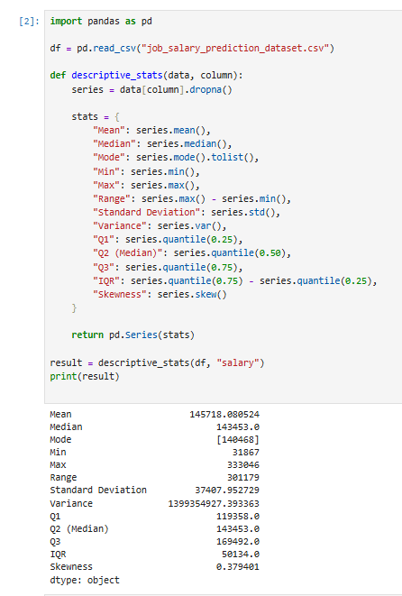

2.3 RANDOM SAMPLING
This is the random sampling of 100 records that we discovered, calculated, and analyzed by python.
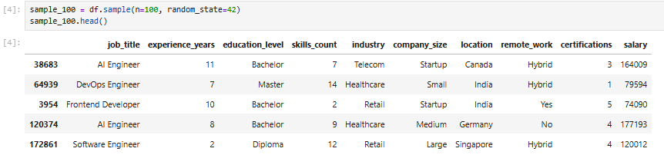

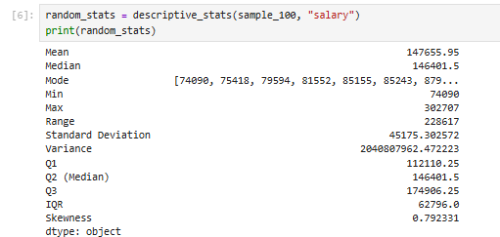

2.4 SYSTEMATIC SAMLING
This fixed intervals was used to create a systematic sample.
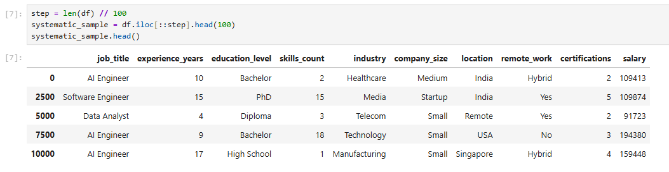
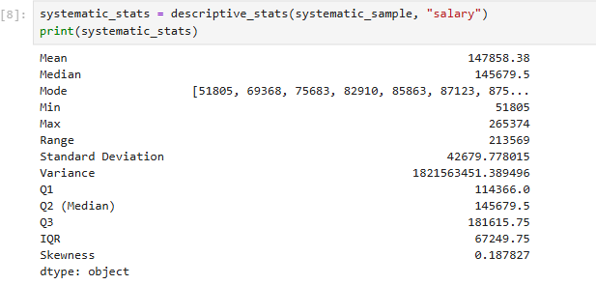

2.5 INTERPRETATION OF DESCRIPTIVE STATISTICS

The descriptive statistics of salary provide important insights:

- The mean represents average salary
- The standard deviation shows salary variation
- Quartiles divide employees into salary groups
- IQR shows spread of middle values
- Skewness indicates distribution

Interpretation:
- If skewness > 0 → more employees earn lower salaries
- If skewness < 0 → more employees earn higher salaries

2.6 VISUALISATION THROUGH VARIOUS CHARTS
We identified patterns and relationships in the dataset with the help of visualization.

Boxplot:
The boxplot shows the distribution of salaries across different job titles. It helps identify the median salary, spread of salaries, and possible outliers for each job category.

Scatter Plot:
The scatter plot shows the relationship between experience years and salary. It helps determine whether salary increases as experience increases.

Histogram:
The histogram displays the distribution of salary values in the dataset. It helps understand whether salaries are concentrated in a certain range or spread across different levels.

Heat Map:
The heat map shows the correlation between numeric variables such as salary, experience years, age, and education level. It helps identify strong positive or negative relationships.

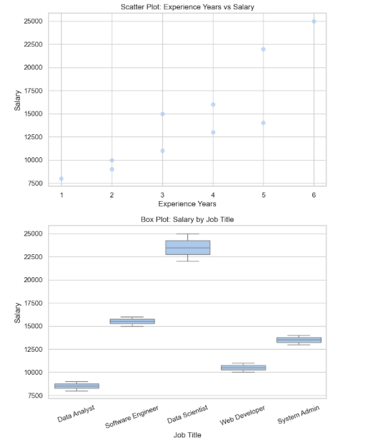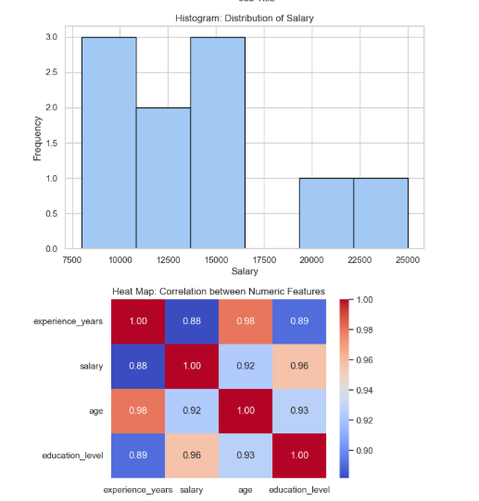

2.7 HYPOTHESIS TEST
1. Pearson Correlation (Numerical vs Numerical)
This test is used to analyze the relationship between experience_years and salary, as both variables are numerical.

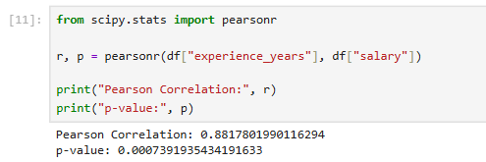

Interpretation:
The Pearson correlation measures how strongly experience is related to salary.
- A p-value below 0.05 indicates a statistically significant relationship
- A p-value above or equal to 0.05 indicates no significant relationship
This helps determine whether increased experience leads to higher salary levels.

2. Spearman Correlation (Ordinal vs Numerical)
This test evaluates the relationship between education_level and salary. Since education level follows an order (e.g., Diploma → Bachelor → Master), it is treated as an ordinal variable.

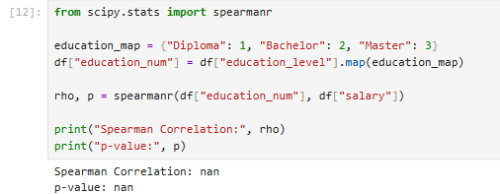

Interpretation:
The Spearman correlation checks whether higher education levels are associated with higher salaries.
- If p < 0.05, there is evidence of a meaningful relationship
- If p ≥ 0.05, no strong relationship is found
This analysis shows whether education level influences salary ranking.

3. Chi-Square Test (Categorical vs Categorical)
The Chi-square test is applied to examine the association between job_title and salary_category.
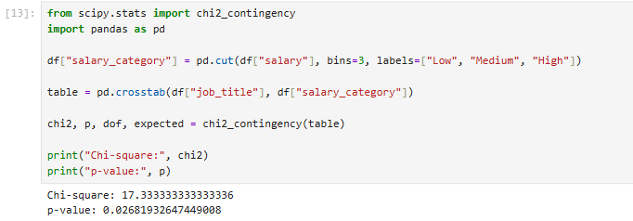

Interpretation:
The Chi-square test determines whether job titles are linked to different salary levels.
- If p < 0.05, job title and salary category are related
- If p ≥ 0.05, there is no significant association
This helps identify whether certain job roles tend to fall into specific salary ranges.

2.8 ONE SAMPLE TEST
The one-sample t-test is applied to determine whether the selected sample data accurately represents the overall dataset.

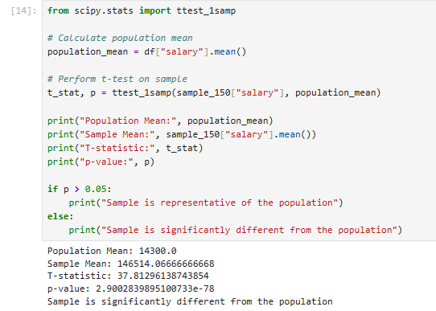

Interpretation:
The one-sample t-test is used to compare the average salary of the sample with the overall average salary of the dataset.
- If the p-value is greater than 0.05, it means there is no significant difference, and the sample can be considered representative
- If the p-value is less than 0.05, it indicates that the sample differs significantly from the population
This test helps verify whether the selected sample provides a reliable representation of salary trends in the dataset.

